5G Lighting Control Ball QC-B1

Product Overview
The QC-B1 series high-definition lighting deployment ball is a comprehensive intelligent emergency deployment terminal that integrates nighttime illumination, smart recognition, high-definition video acquisition, H.265 encoding/decoding, 4G/5G transmission, and strong magnetic adhesion. Featuring high integration, full functionality, portability, and instant deployment capabilities, it operates without geographical or temporal constraints, making it ideal for round-the-clock emergency deployment scenarios.
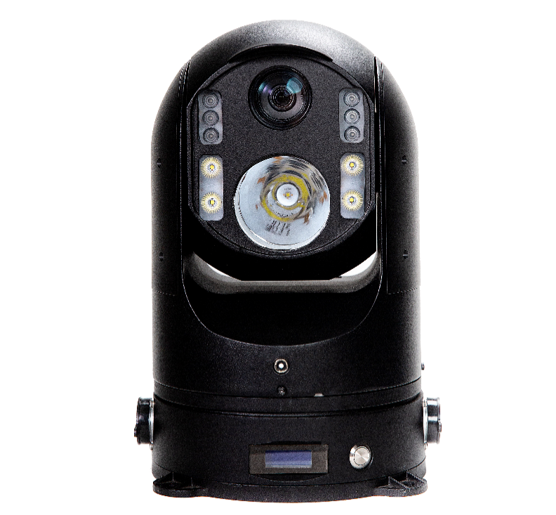

functional characteristics
300 meters; spotlight illumination
LCD display power-off handling
2TB hard drive for expanded storage
2 SIM cards for multi-card aggregated transmission
IP66 protection rating
500 meters laser night vision
Power bank with multiple power supply modes
Dual TF cards + External USB drive for storage
HD 1080P dual-stream transmission
Beidou/GPS precise positioning

Specification Parameters
project | technical parameter
imaging sensor | 2 million CMOS sensors
minimal illumination | Black and white mode: 0.0002 lx; Color mode: 0.0004 lx
Zoom factor | Focal length: 4.6 mm to 152 mm; 30x optical zoom & 16x digital zoom
Backlight | Spotlights + floodlights + infrared lights (Laser version: laser lights + floodlights)
Light Mode | Automatic, Manual, License Plate, Infrared
Cloud Platform | Horizontal 360°, Vertical-30° to 60°,255 preset positions
video coding | H.265/H.264
Video Resolution | 1080P/720P/D1/CIF
Audio Encoding | AAC/AMR/G.711
pickup | Built-in microphone, supports hands-free microphone and Bluetooth
networking protocol | Supports TCP/IP, HTTP, DHCP, DNS, RTP/RTCP, RTSP, and PPPoE
wireless network | Supports dual SIM cards and 5G, with backward compatibility to 4G
Wi-Fi | Supports switchable AP hotspot functionality
PDA | support
show | The LCD display shows status information such as 4G/5G signals, positioning signals, and battery capacity.
TF Card Storage | Supports dual TF cards; a single card has a maximum capacity of 512 GB.
Hard disk storage | Supports external hard drive storage, up to 2 TB
fixed position | Beidou+GPS dual-mode positioning
AI characteristic | Face recognition, License plate recognition
power supply mode | 7.5Ah lithium battery power supply/Power bank/Solar charging kit
continuation of the journey | Depending on the lighting configuration, a single battery provides a range of 2 to 6 hours.
levels of protection | IP66
way to install | Magnetic adsorption, fixed bracket, tripod installation
work environment | Working temperature: -20°C to +55°C; Working humidity: 93%
Weight and Size | 6.7 kg (bare machine); Φ230×320 mm

application scenarios

Nighttime emergency rescue operations
This equipment is suitable for nighttime disaster rescue operations involving earthquakes, floods, landslides, and fires. It features built-in 300-meter high-intensity illumination and 500-meter laser night vision, enabling extensive lighting coverage and high-definition surveillance in complete darkness. Real-time transmission of rescue footage provides critical support for nighttime command, search-and-rescue operations, and demolition tasks.

The police have established a temporary, nighttime security presence.
Designed for public security scenarios such as nighttime checkpoint inspections, arrest operations, emergency response, and covert surveillance. The integrated lighting and monitoring system allows flexible activation of illumination/infrared/laser modes as needed, supports real-time 5G video transmission, and features facial/license plate recognition capabilities, meeting both requirements for nighttime covert deployment and high-intensity law enforcement operations.

Management of Traffic Nighttime Accidents
This equipment is suitable for nighttime traffic accidents on expressways, national/provincial highways, and urban roads, as well as road construction and traffic control operations. It features rapid deployment, powerful illumination for site lighting, 360° panoramic recording via a pan-tilt head, and 5G synchronous data transmission, facilitating remote liability determination, traffic management, and enhanced safety during nighttime operations.

Nighttime emergency repairs for power grids, railways, and pipeline networks
Designed for nighttime emergency repairs of power lines, substations, railway lines, oil and gas pipelines, and municipal utility networks. It can operate independently using built-in batteries even without external power supply, featuring dual functions of illumination and monitoring. The system comprehensively records the entire construction process, enabling remote supervision and safety protection.

Nighttime security for large events
Security duty for large-scale nighttime events such as concerts, competitions, gatherings, and park night markets. The equipment provides extensive lighting and supplementary illumination, while simultaneously enabling video surveillance, crowd monitoring, and abnormal behavior alerts, ensuring both lighting safety and visual command capabilities to enhance nighttime security effectiveness.

Supervision of nighttime construction at construction sites/mines
Continuous nighttime construction scenarios such as construction sites, open-pit mines, and industrial park operations. Intense lighting meets the requirements for nighttime operations, while high-definition surveillance provides real-time monitoring of construction compliance, personnel safety, and vehicle movements. AI technology identifies violations, enabling uninterrupted 24-hour supervision.

Nighttime inspection of water resources / rivers / dams
This system is suitable for nighttime flood control patrols in rivers, reservoirs, dams, and irrigation areas. In dark environments, it utilizes laser night vision and high-intensity lighting to monitor water levels, bank conditions, and unauthorized intrusions in real time. With 5G remote data transmission, it provides round-the-clock support for flood control operations.

Wilderness/Night reconnaissance and search
Complex nighttime environments such as mountain rescue operations, missing personnel searches, field evidence collection, and border patrols. Advanced technologies including high-intensity long-range illumination, laser night vision, 5G transmission, and GPS positioning enable rapid target localization, significantly enhancing nighttime search efficiency and personnel safety.

Nighttime security for the park/ parking lot/ factory area
High-risk nighttime security areas such as industrial parks, logistics parks, parking lots, and factory premises. The equipment features magnetic attachment/quick-installation tripods, combined with lighting deterrence and surveillance video recording, supporting license plate/face recognition technology to effectively prevent security incidents including theft, vandalism, and unauthorized intrusion.

Emergency lighting and temporary command post
This device is suitable for scenarios without electricity or lighting, such as power outage sites, emergency command posts, and temporary security checkpoints. It integrates high-power illumination, video surveillance, mobile power supply, and network relay capabilities, serving as a multifunctional command terminal for nighttime emergency operations.

